

**INT 219 – Front End Web Development Project: eCommerce**

**Name:** Sanskar Mandothia

**Reg. No:** 11811407

**Roll No:** A24

**Section:** KM082

Under the Guidance of **Mrs. Ruchita Duggal**

**MODULES USED:**

**Navigation Bar:**

Navigation Bar helps to link to different sections of websites by showing a list of links at the top or bottom of the website.

Used Bootstrap 4 for this module.

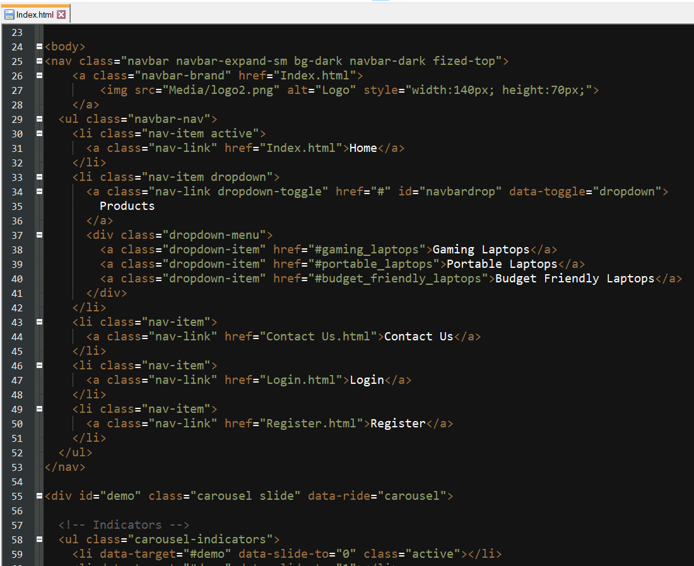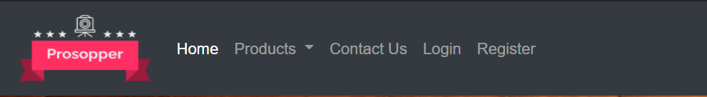

**Image Carousel Slide:**

Shows automatically changing images through a list of selected images. This was done with the help of Bootstrap 4.

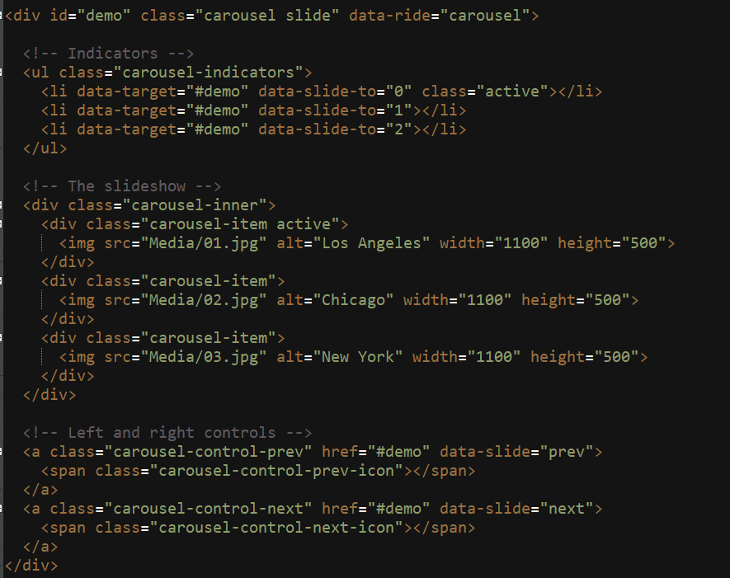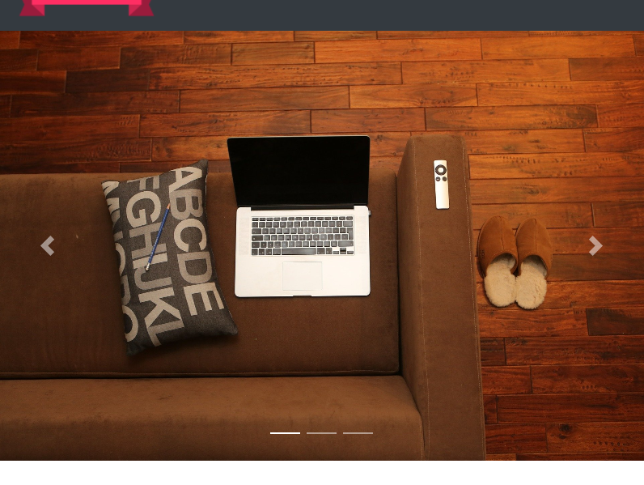

**Sliding Toggle:**

Shows extra panel with animation when clicked on itself. Allows opening as well as closing. Used jQuery for the module.

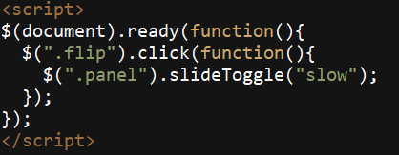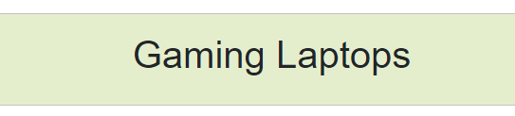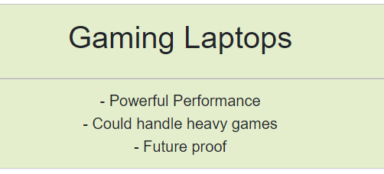

**Flex Box:**

Responsive division boxes which allows to make content in such a way that it appears correct across all screen sizes. Used HTML & CSS.

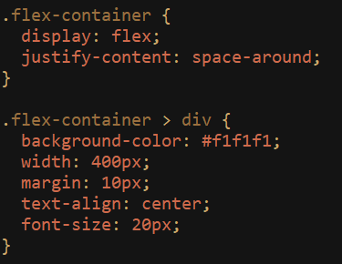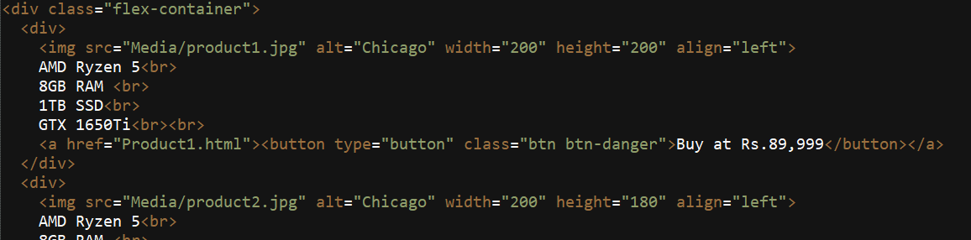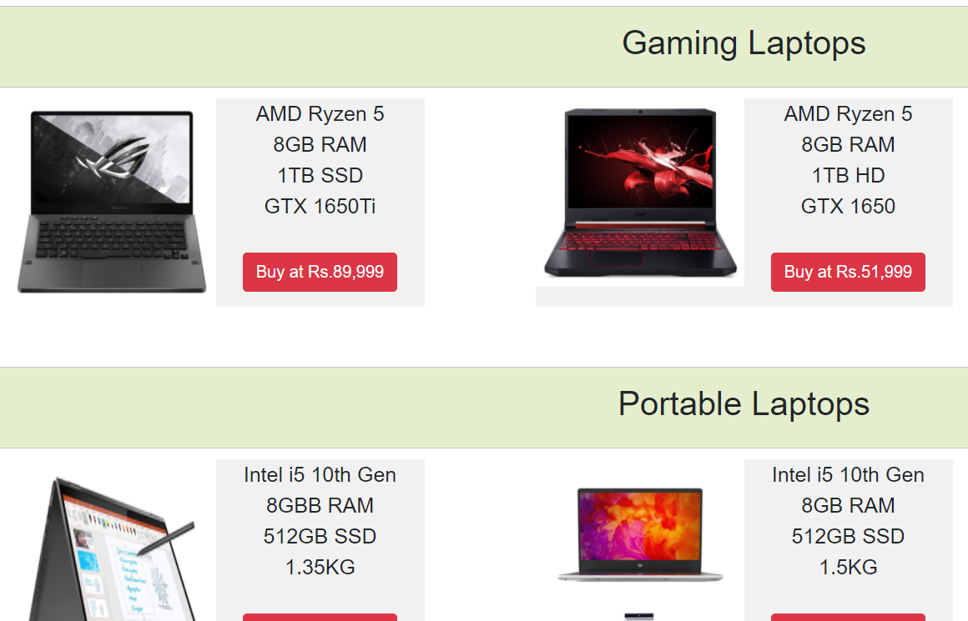

**Hyperlinks: Guides**

Shows users links to open and visit another sites or another page within the website. Used pure HTML.



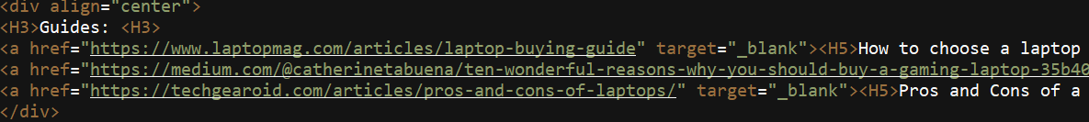

**Login/Registration/Contact Form**

Allow users to login/register or contact the admin using form. Only frontend. Used HTML, CSS & JavaScript.

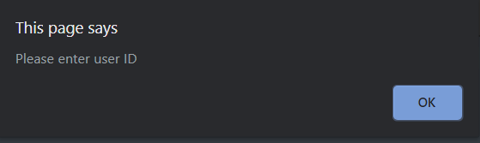

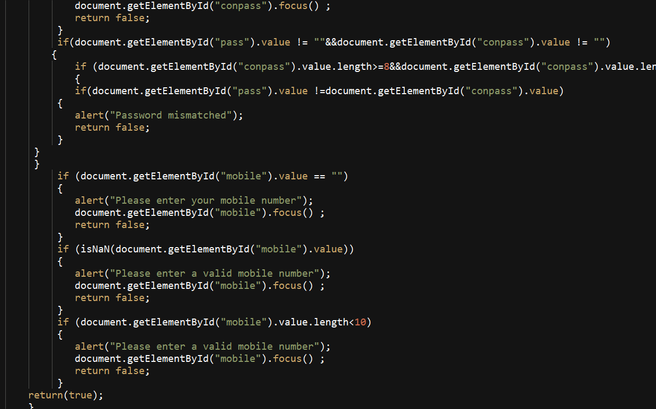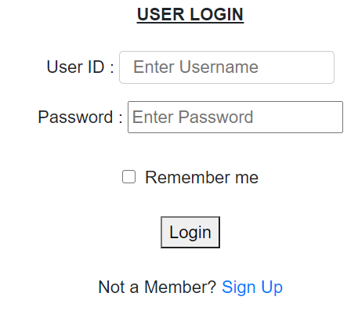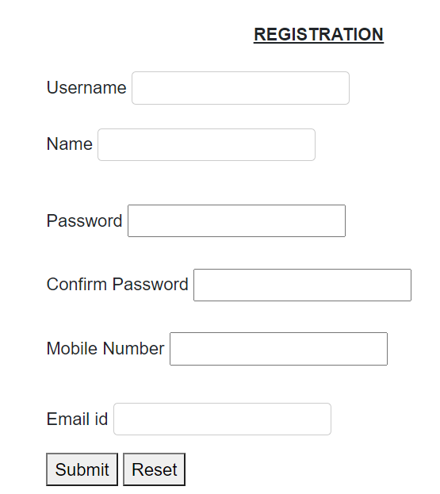

**Product Page with Buy Button**

Allows users to buy any product through Buy button which was created using Bootstrap4 which redirects users to Payment page.

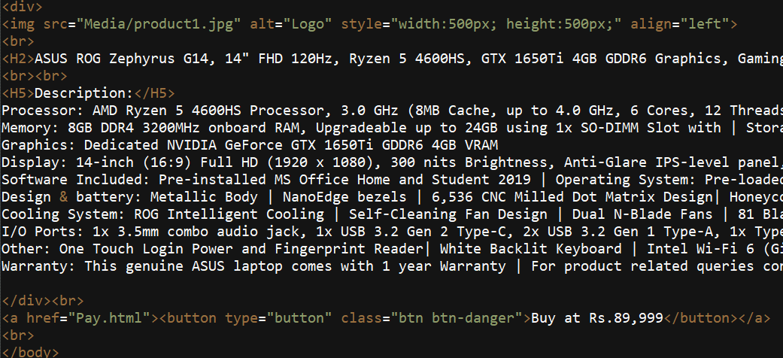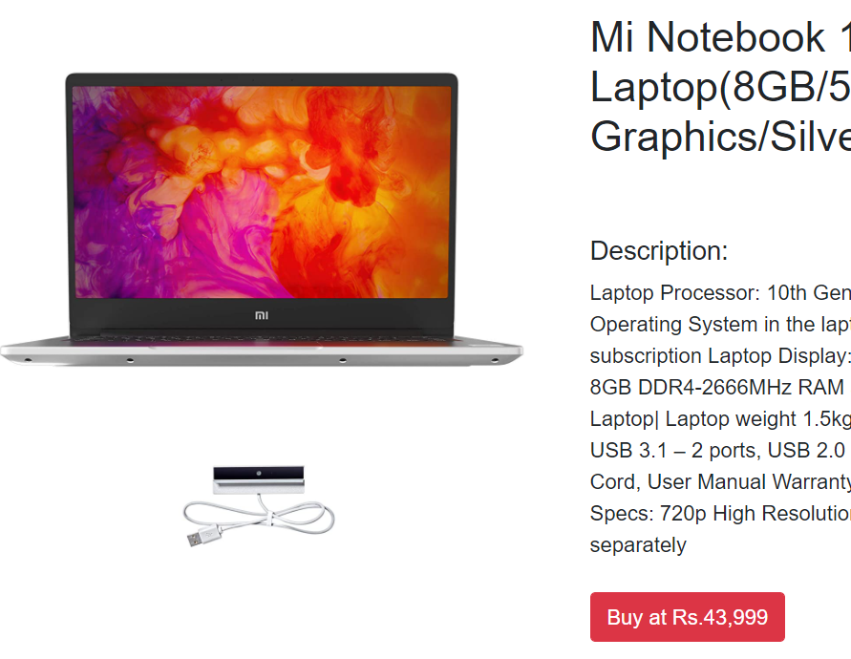

**GitHub Link:** <https://github.com/S4NSKAR/eCommerce-Lite>

**Video Link:**

<https://drive.google.com/file/d/1y53eCSugnCTCh0gRjRV9wJ04p2FZOKM_/view?usp=sharing>